🡺 Open Below Link on browser

<https://notepad-plus-plus.org/downloads/>

🡺 CLICK ON LATEST ONE

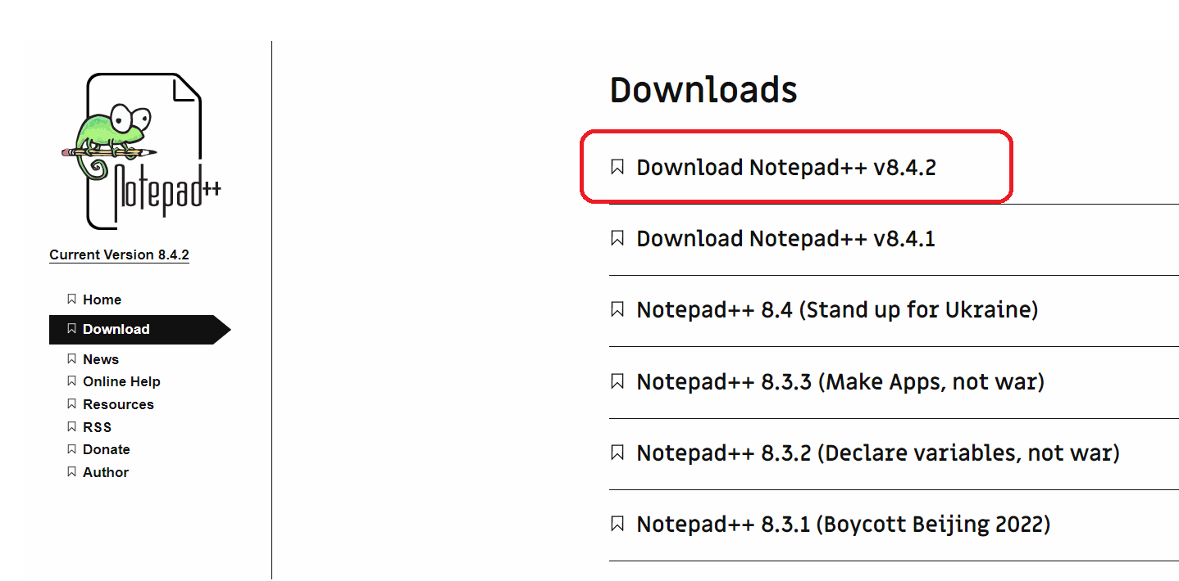

* Click on DOWNLOAD button

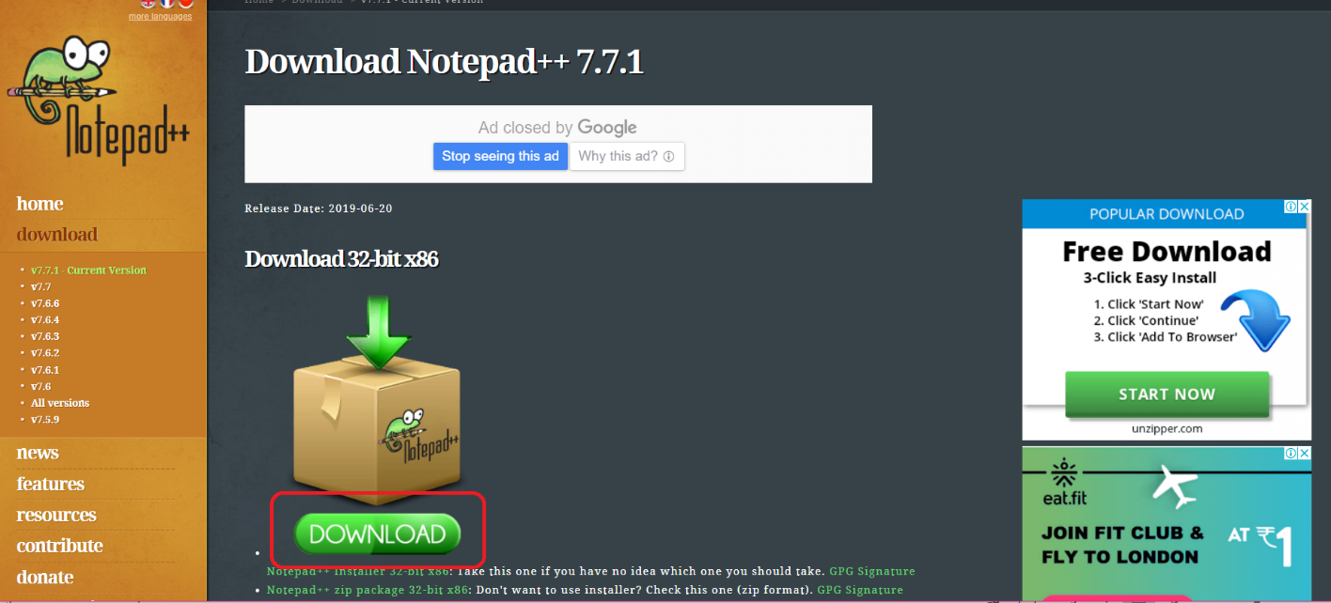

* It will download installer file in downloads path
* Double click on this file

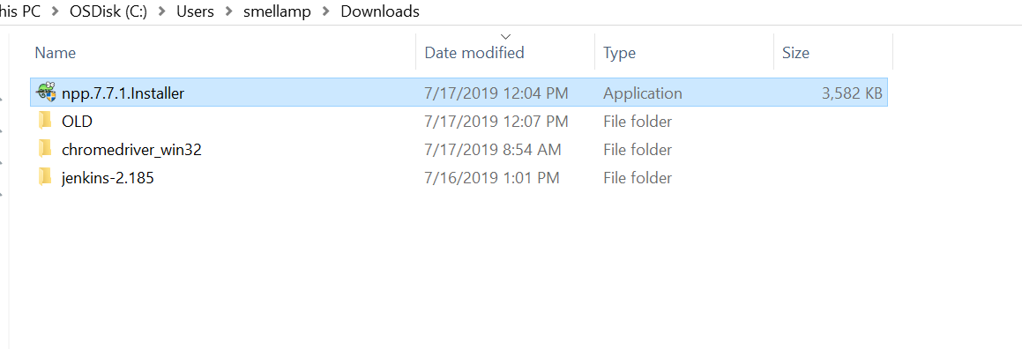

* Then it will raise a popup like below
* Click on Yes

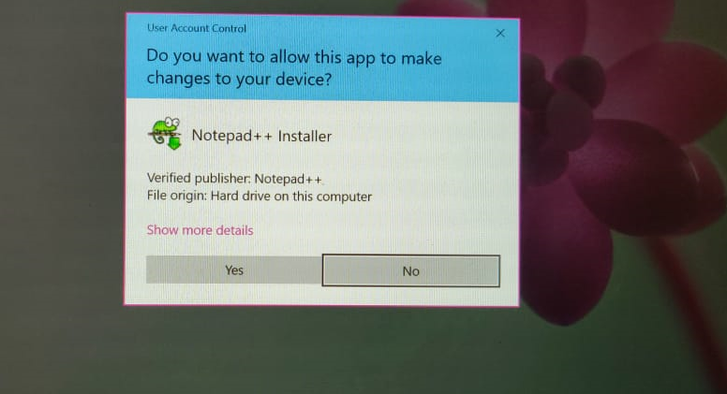

* Then click on OK

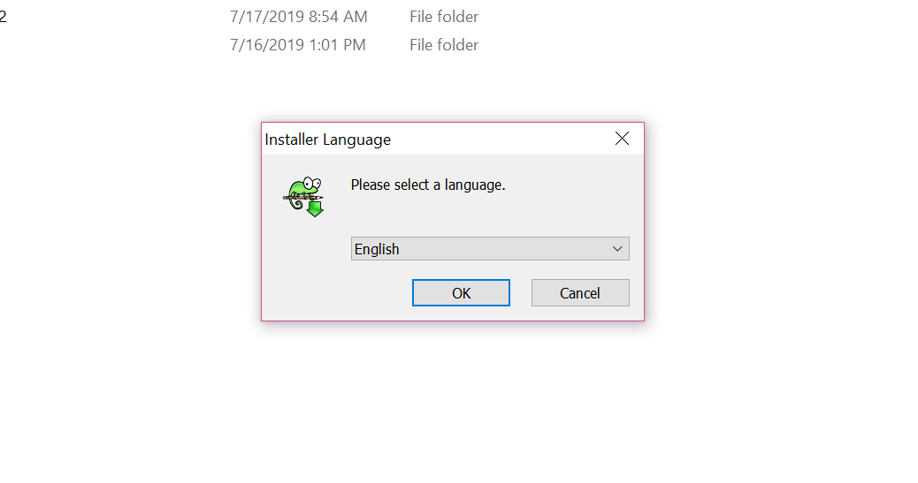

* Click on Next

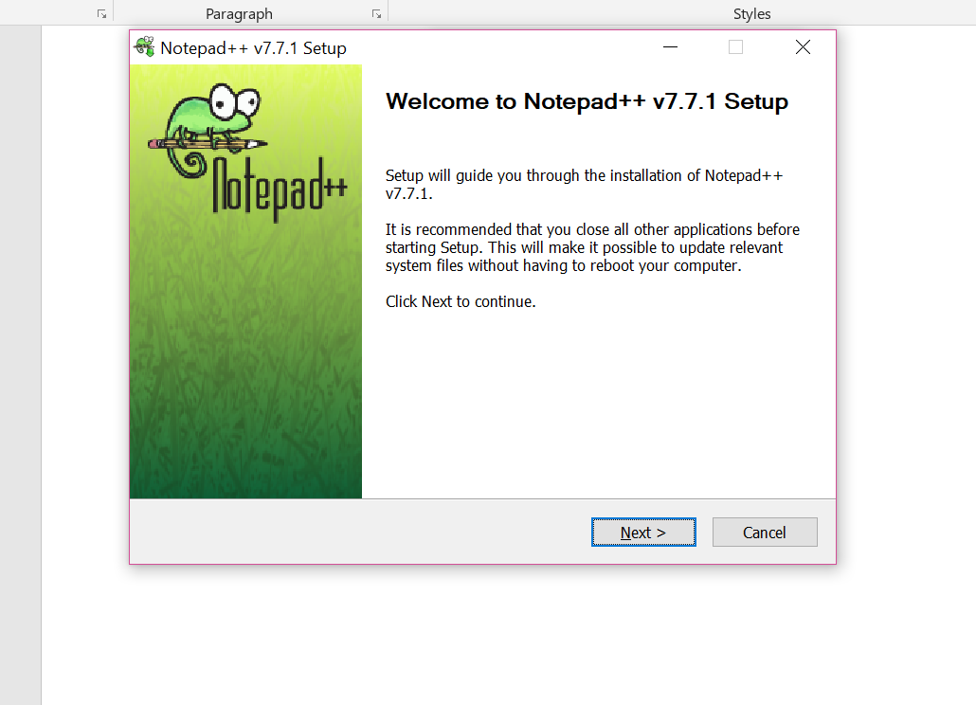

* Then click on I Agree button

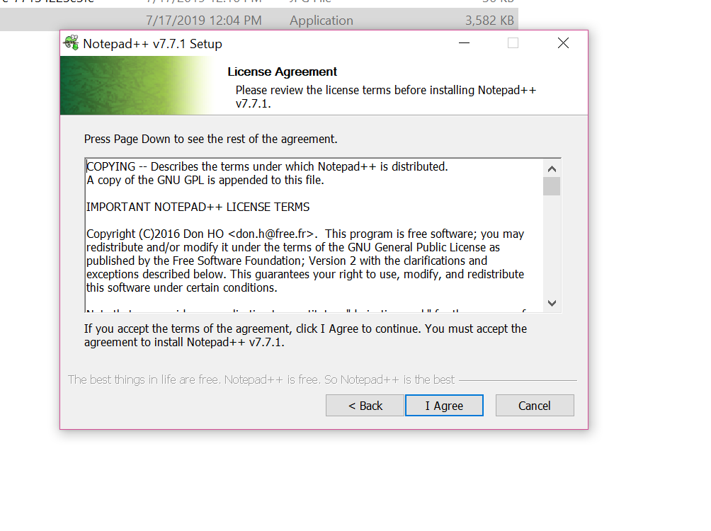

* Click on Next

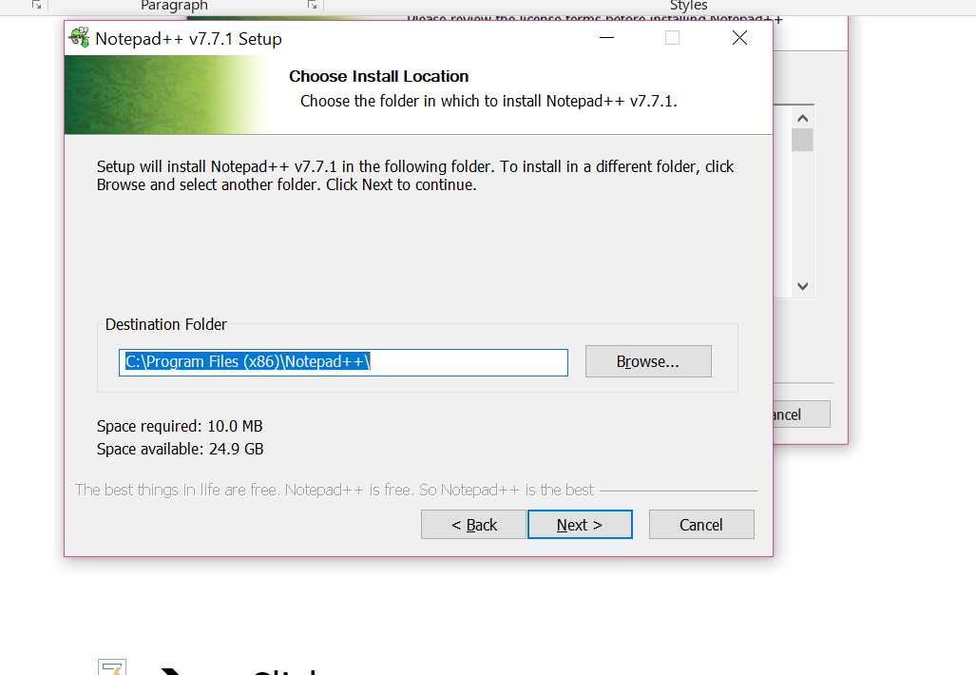

* Then click on Next

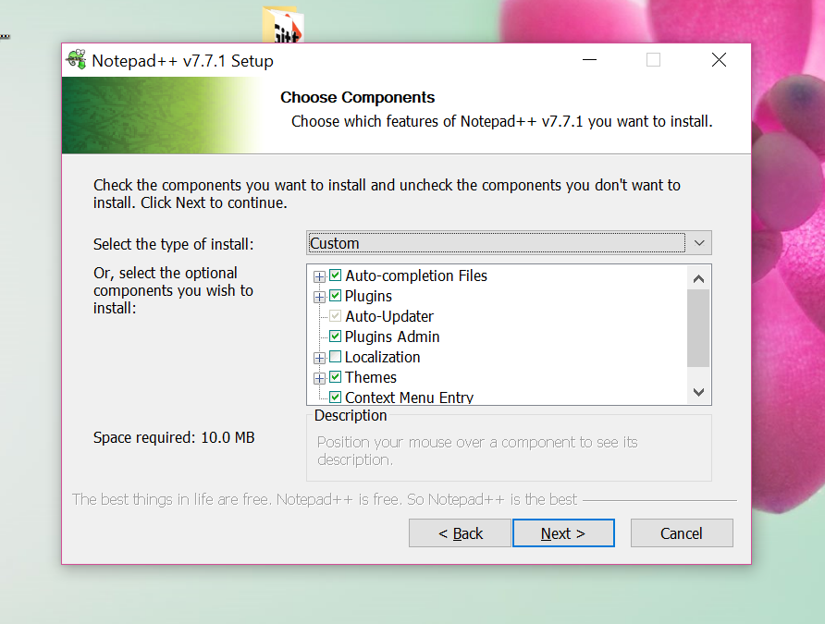

🡪 Select Create shortcut on desktop check box

* Then click on Install

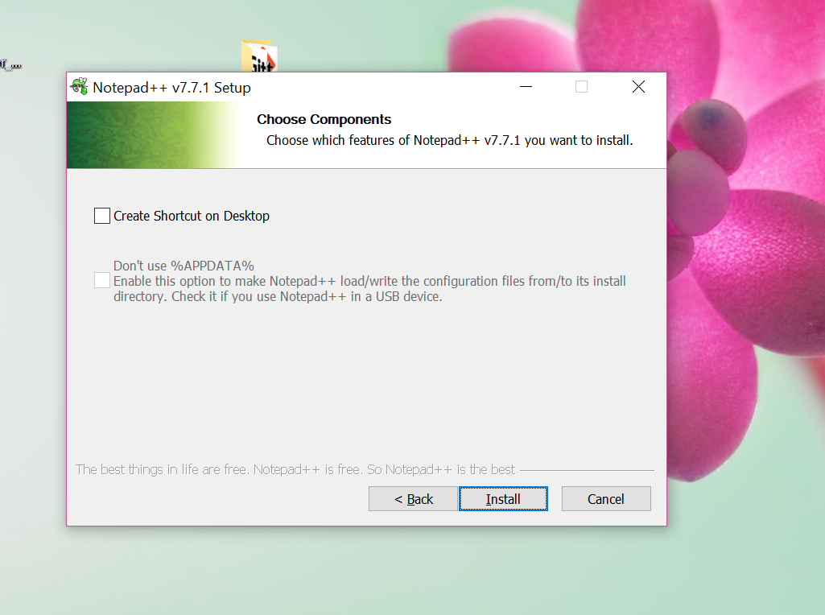

* Then click on Finish

